ASSIGNMENT 4

TEAM ID : PNT2022TMID26692

NAME : MARKANTONY P

REGISTER NUMBER : 212919205025

**CODE:**

|  |
| --- |
| #include <WiFi.h>  #include <PubSubClient.h> WiFiClient;    #define ORG "nhpwjc"  #define DEVICE_TYPE "NodeMCU"  #define DEVICE_ID "USE YOUR ID"  #define TOKEN "USE YOUR TOKEN"  #define speed 0.034 char server[] = ORG  ".messaging.internetofthings.ibmcloud.com"; char publishTopic[] = "iot-2/evt/Data/fmt/json"; char topic[] = "iot-2/cmd/home/fmt/String"; char authMethod[] = "usetoken- auth"; char token[] = TOKEN; char clientId[] = "d:" ORG ":"  DEVICE_TYPE ":" DEVICE_ID; PubSubClient client(server, 1883, wifiClient); void publishData(); const int trigpin=5;  const int echopin=18;  String command;  String data=""; long  duration; float dist; void  setup()  {  **Serial**.begin(115200); pinMode(trigpin, OUTPUT); |

|  |  |  |
| --- | --- | --- |
| pinMode(echopin, INPUT); wifiConnect(); mqttConnect();  } void loop() {  publishData(); delay(500);  if (!client.loop()) {  mqttConnect(); } }  void wifiConnect() {  **Serial**.print("Connecting to "); **Serial**.print("Wifi");  WiFi.begin("Wokwi-GUEST", "", 6); while (WiFi.status() !=  WL_CONNECTED) { delay(500);  **Serial**.print("."); }  **Serial**.print("WiFi connected, IP address: "); **Serial**.println(WiFi.localIP());  }  void mqttConnect() { if (!client.connected()) {  **Serial**.print("Reconnecting MQTT client to "); **Serial**.println(server); while  (!client.connect(clientId, authMethod, token)) { **Serial**.print("."); delay(500);  } initManagedDevice();  **Serial**.println(); } }  void initManagedDevice() { if (client.subscribe(topic)) {  // Serial.println(client.subscribe(topic)); **Serial**.println("subscribe to cmd OK");  } else {  **Serial**.println("subscribe to cmd FAILED"); } } void publishData()  { digitalWrite(trigpin,LOW); digitalWrite(trigpin,HIGH); | | |
| delayMicroseconds(10); digitalWrite(trigpin,LOW);  duration=pulseIn(echopin,HIGH); dist=duration*speed/2; if(dist<100){ String payload = "{\"Alert distance\":"; payload += dist; payload +=  "}";  **Serial**.print("\n");  **Serial**.print("Sending payload: "); **Serial**.println(payload); if  (client.publish(publishTopic, (char*) payload.c_str()))  **Serial**.println("Publish OK");  } else {  **Serial**.println("Publish FAILED"); } } } | { | |

**CONNECTIONS:**

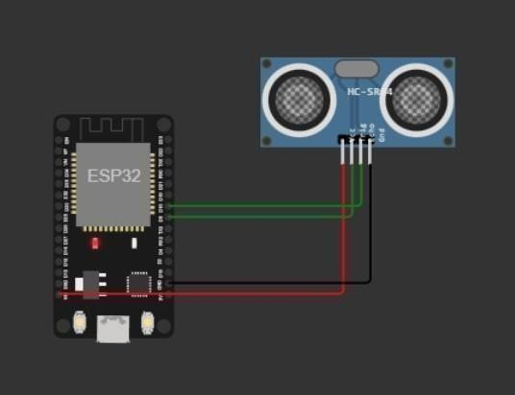

**OUTPUT:**

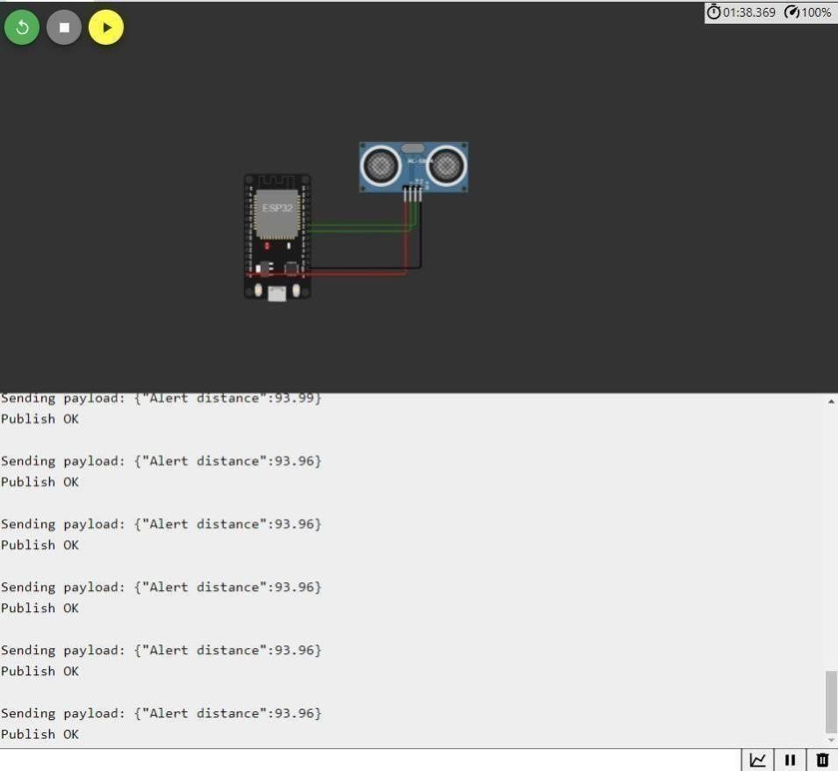

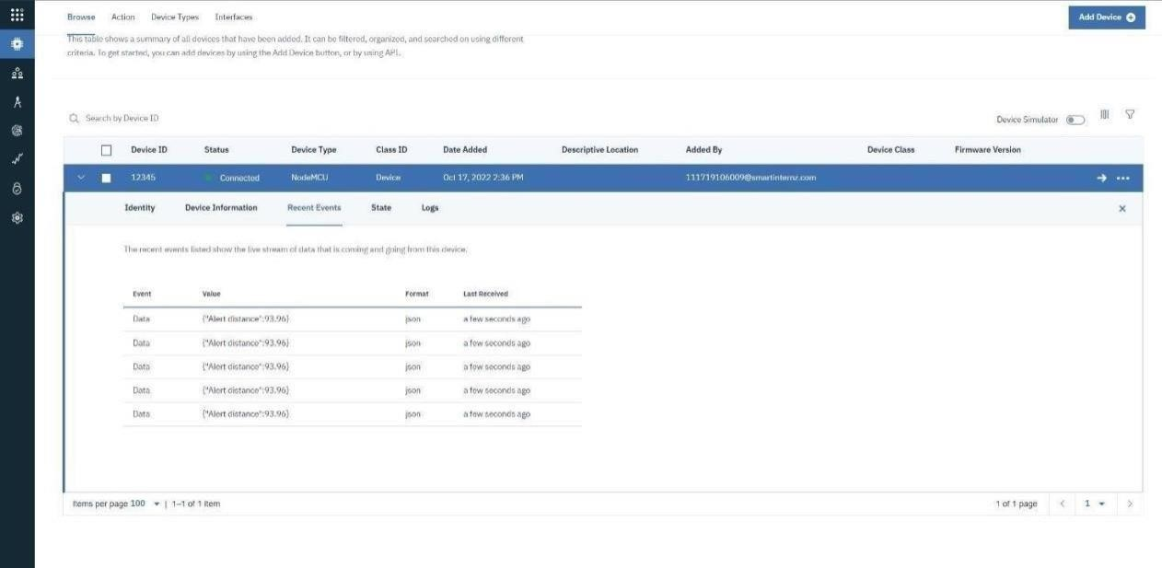

**WOKWI LINK -** [**https://wokwi.com/projects/346405970317935188**](https://wokwi.com/projects/346405970317935188)